Leadership in the 21st Century: Lessons That I Have Learned From Leading and Learning

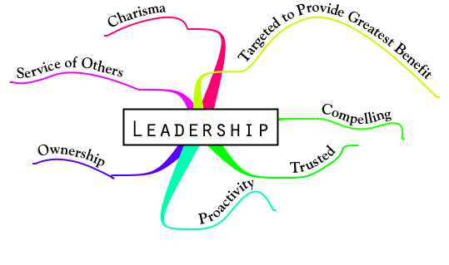

By: Roy Chan
Student ID: 94105908

Instructor: Stephanie Di Alto, Ph.D.
Lecturer, Department of Political Sciences
School of Social Sciences
Program Co-Coordinator of Journal of the Indigenous Policy Network (IPN)

Term: Fall 2008 Quarter
Date: December 3, 2008

Leadership Journal Assignment #1: Complete the self-awareness exercise on p. 14 in Shaw

In Kenneth A. Shaw chapter “Leadership Defined & Explained” in The Intentional Leader, he outlines that leaders do leadership in four ways: 1) envision, 2) articulate, 3) implement, and 4) serve. Shaw defines leadership as “a process of persuasion and example, by which others are motivated to take action” (Shaw 5). In other words, he sees leaders as people who understand the mission, values, and vision of the institution or group. On page 14, Shaw uses the self-awareness exercise in his book as an opportunity for us to look at back on specific areas where we are strongest at and areas we need some work. The author asks us what our own personal strengths and weakness as a leader, particularly in the four tasks of envision, articulate, implement, and serve. After reviewing the chapter, I believe two of the strongest qualities that I have is to envisioning a mission and implementing those goals and values in the business organization. For envisioning, I believe that I am very good in fulfilling a direction because I always have a clear sense of where we need to go to in order for me move the company or group forward. During my free time, I like to reflect on how I could bring change into an organization through a vision or direction that I establish. In addition, I like to think about how I could bring change right by having a common vision right here at the UC Irvine campus this academic year. Every academic year I like enter UCI with a new vision or mindset that I desire to achieve on campus. One of those visions is to invest more in authentic relationships with my friends and faculties here at UCI. As a fifth year, I would like to leave my undergraduate experience knowing that I have a group of friends who would look up to me as one of their best friend in college. We live in a society where it is easy for one to feel very lonely or depressed. I hope that by establishing more meaningful relationships, I would leave UCI knowing that I have a group of friends that I could keep in contact with after my college years. I hope achieve this vision by attending more social events and becoming more social through campus organizations and social outings. In addition to a vision, I believe that I am also good in implementing a goal or value into action. I consider myself to be very self-driven and motivated because I am a very independent and professional person who likes to take the initiative in everything that I do in order to fulfill a mission, goal, or value. I am a person who likes to put things into action, and like to see things happening. As Shaw simply puts it, “If we don’t implement, nothing’s going to happen” (Shaw 11). I am confident in saying that implementing is one of my top strength as a leader. Aside from my personal strengths, one of my weaknesses is to articulate a mission, goal, or value. I consider myself to be somewhat of a shy person. I am sometimes afraid to voice my opinion when the situation arises because of fear that my thoughts are not helpful to the direction or goal in the organization. I understand that Shaw outlines that “under-communicating the vision stifles innovation” (Shaw 9). In other words, the author believes that not communicating effectively is likely going to hurt the mission of the institution. Moreover, Shaw believes that effective communicators are people who are good in storytelling (Shaw 9). I know that I, as an individual am not a good storyteller. I believe that I can improve on this skill by sharing more of my own personal stories to my parents or roommates during my free time. By becoming a better storyteller, I will not only become a more effective communicator, but I will also become more confident and aware sharing my own personal opinion in a particular institution or group setting. By becoming an effective communicator, I will ultimately be more prepared to articulate my vision and direction to the mission, goals, and values throughout the organization.

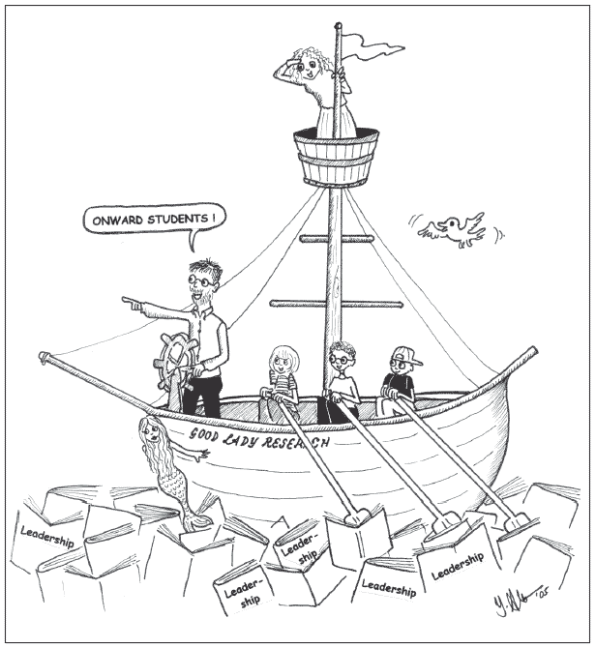

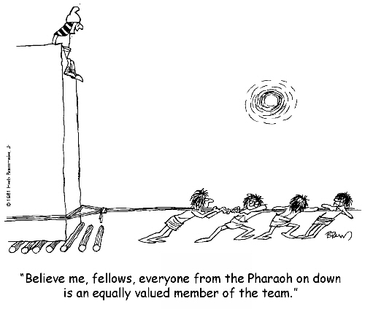
Leadership Journal Assignment #2: Complete the Leadership Trait Questionnaire on p. 30 in Northouse and the Style Questionnaire on p. 51 in Northouse; summarize what you have learned about yourself as a leader from these exercises.

After completing the Leadership Trait Questionnaire on page 30, I noticed that 4 (Agree) was a very common choice that I picked from the questionnaire. Northouse state that “The scores you received on the LTQ provide information about how you see yourself and how others see you as a leader.” After reading that statement, I believe that Northouse would consider me as very agreeable person where others see me as an agreeable leader. I definitely agree with the results of my Leadership Trait Questionnaire because I strongly feel I am a very acceptable, self-confident, and dependable person when it comes down to leading an organization, group, or society. The lowest score that I chose was a 3 (Neutral), where I consider myself neutral when it comes down to discerning and providing insightful information to a group (perceptive). The highest score that I chose was a 5 (Strongly Agree), where I selected that I am very self-confident, determined, and trustworthy.
Unlike the Leadership Trait Questionnaire, the Style Questionnaire on page 51 was very similar in that out of the 20 questions, I chose 4 (Often) 14 times indicating that I am often a very approachable, friendly, and task oriented person in a given organization or society. For the final total of task, I received a score of 46 placing me into the very high range as an indication that I am exceptionally well completing task in a profession and effective matter. For the final total of relationship, I received a score of 40 placing me into the high range category as an indication that I do pretty well in developing strong relationship and trust among to a particular group or organizations. After reviewing those scores, I definitely agree with my result of this test because I consider myself to be very excellent candidate when it comes down to completing task and building trust among my colleagues and peers.

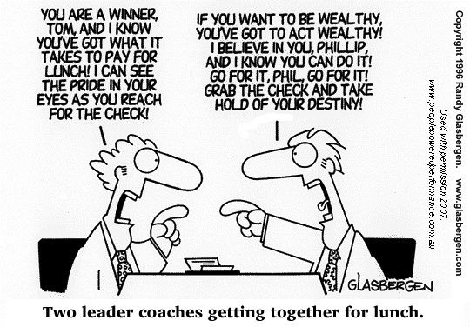

Leadership Journal Assignment #3: What qualities do you admire in leaders? Why do you think these qualities are important?

In James Kouzes and Barry Posner article, “When Leaders Are at Their Best: Five Practices and Ten Commitments” in The Leadership Challenge: How to Get Extraordinary Things Done in Organizations, they outline that there are five practices of exemplary leadership: 1) models the way, 2) inspire a shared vision, 3) challenge the process, 4) enable others to act, and 5) encourage the heart (Kouzes & Posner 2). One of the qualities that I do admire in a leader is those people who do show appreciation to other people and cares about other people’s attitude and emotion in a work place. In most business settings today, many people in America do not take the time or effort to show gratitude to someone for their hard work. We live in a business world where most of us are more focused on ourselves than for others. We seek pleasure because we live in a “me” self culture. I believe that for leaders who do give encouragement to other people are normally those people who love what they do in their job. I think this quality is very important in a leader because I believe an open heart that encourages other to work more better would automatically create a safe and fun working environment where they can model their way of getting tasks done, they can share their ideas and visions to other co-workers, they can expressively challenge the process or idea they are trying to accomplish, and they can enable others to act in ways that would help them complete their assignment in an extraordinary and faster way. In other words, leaders should be the ones who give encouragement to the heart. By encouraging other leaders, they would ultimately instill a sense of knowledge, objective, ingenuity, confidence, and courage, according to John Kunich and Richard Lester article in “Profile of a Leader: The Wallenberg Effect”. The idea of encouragement would create more people to have a higher degree of emotional intelligence, specifically in self-awareness, self-regulation, motivation, empathy, and social skill that are outlined in Daniel Goleman book in “What Makes a Leader?” by the Harvard Business Review.


Leadership Journal Assignment #4: Create a personal code of ethics.
In my personal commitment to educating adults as a University Studies Discussion Leader this fall quarter, I offer the following ten statements as my guiding practice (taken from Edward VanBeers, Elmira College Graduate Student):
- I will conduct myself as an ethical person when dealing with learners, colleagues and others in which I may encounter in all my undertakings.
- I will offer to each adult learner the insight of my combined knowledge and developed skills in a manner that is offered and received without prejudice, judgment, or predetermined notions of any adult learner’s ability, disability, religious beliefs, learning style, age, socioeconomic status, gender, race, and ethnicity.
- I will conduct myself in a supportive, but professional, manner in all my dealings with adult learners and colleagues, setting the standard and putting forth the highest respect in my professional relationships with others.
- I will refrain from any and all activities which may be construed as unethical, or which may violate written and unwritten codes of professional and personal conduct, rules, regulations and similar standards of the profession of adult education, and/or the laws of jurisdictions.
- I will encourage adult learners to participate in the planning and development of their educational experiences to the extent of challenging them to reach their full academic and personal potential, and provide the environment supportive to such self-directed success.
- I will continue my whole-hearted commitment to developing quality programs, tools, resources and delivery methods to the benefit of adult education.
- I will continue the development of myself as a lifelong learner, and professional in the field by seeking personal knowledge, skills and the commitment of my own potential as an adult learner throughout my life, and develop productive and effective systems to create an environment for adult learners conducive to reaching their full learning potential.
- I will practice to the best of my ability the asset of objectivity, and will entertain thoughts of all learners without bias to predetermined beliefs or shadows of conflicting values, morals and/or judgments.
- I will promote ethical thinking and living among those whose paths I encounter in all walks of life, by conducting myself in such a manner as to set the example.
- I will in good faith respectfully negotiate with administrators, adult learners, policy-makers, legislators and others involved in creating rules, codes, laws, expenditures, environments, programs and policies that affect the institution of adult education for the benefit of adult learners, and in accordance with my personal philosophy on adult education.
Reference: VanBeers, Edward. Personal Code of Ethics: A Living Document. February 2001.
< http://home.twcny.rr.com/hiemstra/edcode.html >

Leadership Journal Assignment #5: Identify something that today’s guest speaker said that particularly resonated with you. Explain.

On October 13, 2008, we had a guest speaker come into class to discuss about how to become a successful business person. Though I have forgotten her name, she gave a wonderful discussion on how business skills can be learned without ever entering business school. Our guest speaker brought into class one of her favorite book called, “The Ten-Day MBA: A Step-By-Step Guide To Mastering The Skills Taught In America's Top Business Schools” by Steven Silbiger. She describes how wonderful the book is because it describes every small detail one would learn in a MBA business school into one single book that is divided into 10 chapters. In the book, Silbiger claims that this book contains everything one needs to know in order to become a successful business leader. The author describes several main components of management: marketing, ethics, accounting, organizational behavior, quantitative analysis, finance, operations, economics, and strategy (Silbiger). In addition, he uses real life examples in order to present the material at a high level like one would experience in a business school. One aspect that I have learned from the guest speaker is how basic skills leadership that is normally taught in business school can be learned and be instilled without even going into world of graduate school. The idea of developing business skills without even entering business school is a great example that shows how each leader can develop their leadership skills overtime without ever going to school. In other words, leadership skills can be learned and that there is no such thing as the phrase “I was born to be a leader.” Like leadership skills, business skills can also be learned just by reading Silbiger book called “The Ten-Day

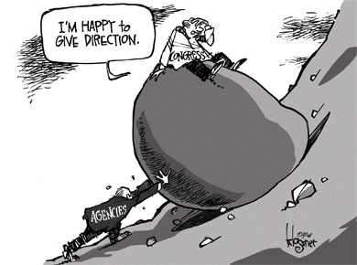A.”

Leadership Journal Assignment #6: What qualities do good followers possess? Why are these qualities important? Are you a good follower?

In James Kouzes and Barry Posner article, “What Followers Expect of Their Leaders: Knowing the Other Half of the Story” The Leadership Challenge: How to Get Extraordinary Things Done in Organizations, the author outlines four different characteristics that every leaders must possess: 1) honest, 2) competent, 3) forward-looking, and 4) inspiring. Through these qualities, the follower would develop a more trusting relationship with the leader, they would do what the leader tells them to do, they would acquire knowledge and skill from the leader to lead the organization, and they would find passion with what they are doing for the company. I believe a good follower is those who can challenge the organization to foster change and growth and those who can take risk and learn from their mistakes. These qualities are often used when followers feel inspired, motivated, energized, and proud of what they accomplishing (Kouzes & Posner). I believe that these qualities are important because they enable both the leaders and followers to equally get things done in an extraordinary way rather than making the leaders does all the work on their own. Moreover, these qualities can help develop a better relationship between the two rather than creating a hierarchy between the leader and the follower. The concept is clearly emphasized in Thane Pittman, William Rosenbach, and Earl Potter article, “Followers as Partners: Taking the Initiative for Action” in Contemporary Issues in Leadership,” where the authors believe that the relationship between the leader and the follower is the most important factor for every organization to be an effective or successful company in the long run. They discuss throughout the article how the relationship between the leader and the follow should be the similar rather than different. They state that, “Followers should be seen as active contributors, not passive recipients of order (Pittman, Rosenbach, & Potter 107).” By creating equal task between the leader and the follow, each organization can clearly feel inspired, motivated, energized, and proud of what they accomplishing in the long run. I believe that I am not a good follower because I am sometimes shy or afraid to share my own ideas or opinions to other people of fear that what I have to say is not important or worth to be in consideration.

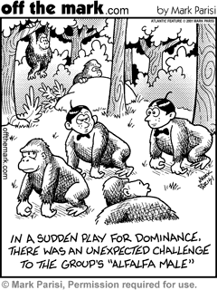
Leadership Journal Assignment #7: Complete the first self-awareness exercise on p. 100 in Shaw.

In Kenneth Shaw chapter “Leading Groups” in The Intentional Leader, he believes that groups can be destructive, ineffective, conservative, and uncreative (Shaw 81). The author outlines that there are three major aspects one must understand about groups: 1) group purpose, 2) group size, and 3) group function. In group purpose, he believes that one must be capable enough to explain the group purpose of what the organization is supposed to do in a given situation. Shaw believes that the main purpose of groups is to give information, to give and receive information, to make decisions, to develop new ideas, to resolve differences, and to achieve understanding of a decision (Shaw 84). By achieving these core values, one can easily make legitimate decisions more effective and quicker. In group size, Shaw believes that a group size can determine how the structure of the meeting will run. The smaller the group, the more open people are to share their opinions to the group. The larger the group, the more different views and methods can be used to fulfill a mission, goal, and value. In other words, the group size can play a large role of how the company will fulfill their vision or direction
1) One of main aspect the author discusses is the difference between positive group roles and negative group roles. Positive group role is the ability to get certain things started, proposing a task to be done, and to suggest a procedure to get the ball rolling. If group needs aren’t met, then one can reinforce positive group behavior by being a good example to your group and evaluating the progress the group has made. I believe that I am best when I meet socio-emotional needs because I like to offer inputs and friendly comments to each individual. I believe that by encouraging others, I would create a friendly and open environment where everyone is willing to offer their opinions. One aspect that I wish I could improve on is summarizing what is being said and put them together by restating them in my own words and offer the group to accept or reject the idea. Sometimes I get very confuse with what is being said, and that I would have difficulties using words to summarize in one sentence what he or she is trying to imply. I believe that I could improve on this area by going to class and thinking to myself every ten minutes or so what the teacher is trying to imply in one word, phrase, or sentence. By practicing this every day, I would ultimately improve in summarizing all the person ideas into one sentence during a group setting.
2) Negative group roles occur when one acts negatively to a group situation. Examples are aggression, dominating, blocking, belittling, and being a fool to the group rather than helping them achieve a common goal or end. I have definitely witnessed some negative group roles during my years at UCI. One, for instance, is when one of my group members decided to interrupt and embarrass other in a science project for no reason because he thinks that he is better or smarter than our entire group. Many men, I think, struggle with issues of pride and self-satisfaction. Many guys want to be better than other men because they like fierce competition. By men dominating other people in a group, I believe that this will create a lack of team work and trust because one is dominating over other thinking he can do everything without the groups help. Domination, I think is one of the most negative group acts that occur in many group settings today. I believe that this can be alleviated by removing the individual from the group and telling him or her privately that if his behavior doesn’t change, then the group has the right to remove him or her from our group until his or her behavior changes. By removing a dominant figure from a group setting, this will create more equal opportunities for other group members to fulfill the mission, goal, and value given by the leader.
Leadership Journal Assignment #8: Complete the Passive Bias Quiz passed out in lecture. Briefly discuss the results.
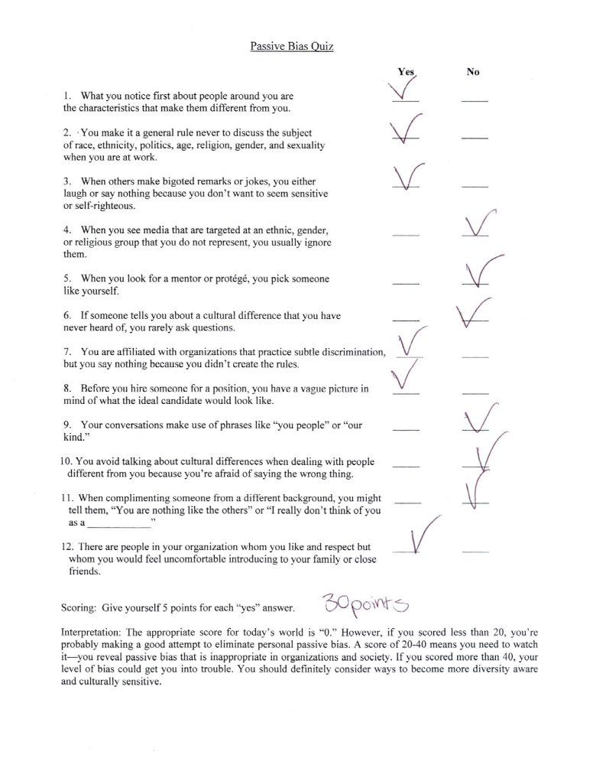
After completing the Passive Bias Quiz, I received a score of 30 points which indicates that I reveal passive bias that is considered to be inappropriate for organizations and society. I definitely agree with this quiz because I feel that sometimes I act inappropriate in the organization that I work with right now. I believe that I tend to make general stereotypes about people as well as make quick judgments very easily that I feel is hurting not only myself but the organization goals and visions that I work with right now. After reflecting about this quiz, I believe that I really need to think more on what types of comments I should be making the next time I talk or think about an individual’s beliefs, behaviors, or views. Making any kinds of judgment or assumption about someone or something on the spot is considered to be a bad strategy for success in any given organization or society. I believe this Passive Bias Quiz really opened my eyes to how passive bias I really can be within my work organization environment.
Leadership Journal Assignment #9: Identify something that today’s guest speaker said that particularly resonated with you. Explain.
On November 10, 2008, we had Prany Sananikone come speak to us about diversity. Sananikone, the Director of Diversity Relations and Office of Equal Opportunity and Diversity (OEOD) at the University of California, Irvine, begins by describing how diverse Orange County is and he considers the OC to be one of the most diverse places to live at in the world. He later discusses about how we as Americans generally make quick stereotypes about people in an organization or society. In addition, he feels that we as Americans are very ignorant when it comes down to describing another culture from other countries in different parts of the world. Sanakikone One aspect that I really enjoyed about today’s guest speaker is simply the way how he teaches. His ability to teach our class about diversity in a very enthusiastic and effective learning environment when English is not his language is an example of a person who has an extraordinary leadership skills we need more at UCI. The way how he incorporates various activities, such as how many squares do we see or as well as to bring an instrument (I think a bell or drum) as a way to make student stay awake in class really shows that he has a unique personality because he doesn’t follow what other teachers do and likes to be creative when teaching his material to the class. He is an example of a person who has an exemplarily leadership talent in the field of teaching because he is not afraid to take risk, he is willing to go out of his comfort zone, he is willing to do more than expected, and that he seeks to be very different from other guest speakers or teachers at UCI. Watching him teach really made me want to become a teacher and utilize his methods into my teaching career in the future.


Leadership Journal Assignment #10: Identify something that today’s guest speaker said that particularly resonated with you. Explain.

As a law school potential, I have really enjoyed having Cyrus Ameri coming over to our class as a guest speaker for our class. I am currently applying to law school right now, and he provided me numerous insights on how can I make my application more competitive for law school this fall. I am currently applying to Harvard Law School, and feel that his advices and words are very helpful and encouraging. One aspect that I learned from Cyrus Ameri is how he stresses the importance of networking. I remembered how he us that networking is such an important aspect for individuals to succeed as a Harvard Law student and as future lawyers. He believes that the ability to network with other law students can help place a strong emphasis on what job an individual can get after graduating from law school. Additionally, I really enjoyed his sense of humor, where on occasion, he would make practical jokes on how he partied a lot during his free time at Harvard Law. I never thought that students at an Ivy League law school would even have the time to even party that much until that day. I also liked how he stresses the importance of being involved in extracurricular activities at UCI and how to get the most out of our undergraduate experience. I liked how he shared his personal experience of being involved in several academia clubs within the political science and sociology department. I believe that he is a great example of a man who knows how to get things done in an effective and professional matter. His passion for the law is really shown by the way how he presented his discussion to our class that day.

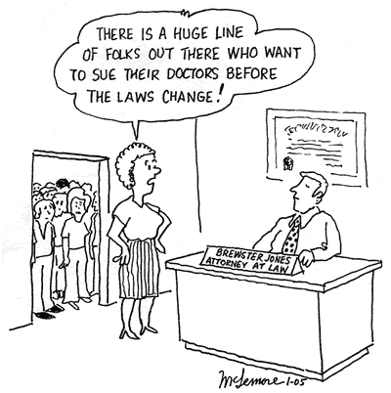

Leadership Journal Assignment #11: What kinds of abilities do citizen leaders have to create change? What can you do as a citizen to exercise leadership in your community?

In the article, “Defining a Citizen Leader” in The Leader’s Companion: Insights on Leadership Through the Ages, Richard Cuto believes that citizen leaderships are people who are willing to seek for change in society. He believes that citizen leaders are people who have strong interest to improve the conditions of people in low income communities as well as to address other basic needs of society at the local level. Many citizen leaders have the ability to become good leaders and the ability to work with other groups and organizations. I believe that citizen leaders are people who have the ability to be very self-motivated, intelligent, determined, confident, and insightful. Moreover, I believe that citizen leaders must have the passion to work with people who are underprivileged and poor. In addition, I feel that citizen leaders need to know when one must go outside his or her comfort zone. While trying to implement change, citizen leaders understand that they will be interacting with numerous people who are emotionally unstable or unemployed. To be able to talk to a community who are under the socio-economic status is going to require the citizen leaders to take risk as well as to go outside their own personal comfort zone in order to implement change. One aspect that I can do as a citizen to exercise leadership in my community is to be involved in community service, such as volunteering at day care center, in a soup kitchen, cleaning the beaches, or even volunteering to tutor in after-school programs. Through these various activities, I am allowing myself to give back to the community and at the same time become a good citizen leader where I am trying to promote change to the community or society.

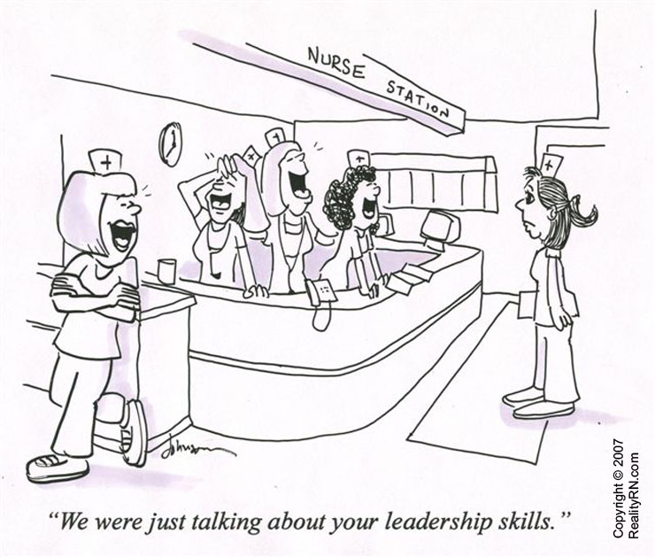

Leadership Journal Assignment #12: Identify something that today’s guest speaker said that particularly resonated with you. Explain.

Leah Ersoylu, Founder, President and CEO of Ersoylu Consulting, came in to our class to discuss about her work delivering policy and advocacy solutions to the public in Southern California. Ersoylu describes how she would assist analyst and researcher in various public policy issues. Moreover, she discusses how government-created mechanisms would hinder or create low-income groups in various levels of public policymaking. In addition, Erosylu talks about how one can become a successful business person in our complex world today. One aspect that I liked was when she mentioned that having a personal website was such an important tool for companies and organizations to get to know the individual. She believes that having a personal website would allow an organization or institution to understand how professional or organized the individual can be. Additionally, I learned from Eroslylu that most companies today would make new prospective employer fill out a bias quiz or survey to determine whether the individual is qualified for the job. She told us that most business organization would utilize this strategy as way for them to measure how long the employer will last in the job and whether or not person will play an effective role within the organization. Overall, Ersoylu provided great valuable hints to students who plan to enter the business world.

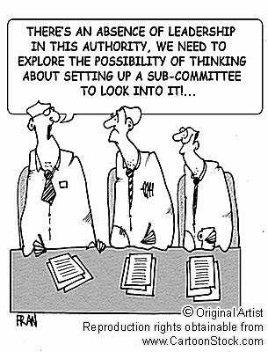

Leadership Journal Assignment #13: What “bad” leadership qualities do you possess? What are your weaknesses as a leader? What can you do to address these weaknesses?

In Barbara Kellerman article, “Reasons For Being Bad” in Bad Leadership, she believes that there are two main categories for bad leader: 1) ineffective and 2) unethical. She outlines that there are seven main types of bad leadership - incompetent, rigid, intemperate, callous, corrupt, insular, and evil. After reviewing the list, I believe that there is one main area that I feel I consider as my weakness as a leader - incompetent. At times, I believe that I am very incompetent when I am asked to do something on the spot. Sometimes I feel that I am a very slow thinker, and thus by putting me on the spot, I will likely to feel very incompetent when fulfilling a particular job or duty. In addition, I believe that I am sometimes incompetent in regards to my own knowledge and experience of a particular field. Currently working in a law office, I believe that there has been numerous occasions where I feel very incompetent doing in a given moment. This may be likely due to by my lack of knowledge or experience in a given area or my lack of interest in regards to the assignment. I believe that my incompetency in my law office would often slow down the work that must be done as well as my co-workers. One example that I can do to address this weakness is to simply tell my boss that I am very incompetent in handling this particular duty and ask him if he can assign me a different task. I normally do not request this action because I feel that my boss would look down at me for my lack of knowledge in this area or may cut down my pay check for not doing a task that I should complete. But in the long run, I believe that I should address this to my boss so I can maximize my time working in the law office rather than wasting my time figuring out how to complete a given assignment or task.

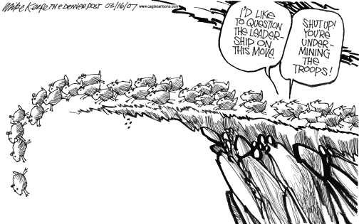
Leadership Journal Assignment #14: Complete Maccoby’s personality survey (posted on course website)



☺ See next page ☺

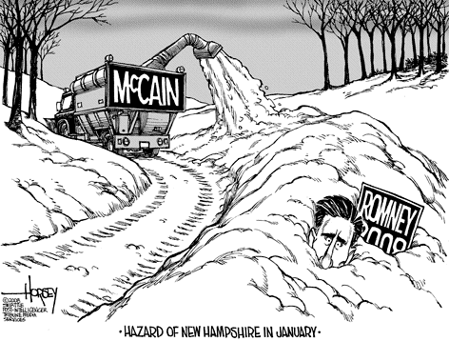
Leadership Journal Assignment #15: What leadership skills needed for the future do you already possess? What skills do you need to develop? How will you go about doing this?

I believe that some of the main leadership skills that I possess are time management, interpersonal, conceptual, public speaking, intrapersonal, communication, analytical as well as other leadership skills that I feel I have developed overtime during my five years at the University of California, Irvine. I also believe that some leadership characteristics that I possess today are intelligence, self-confidence, determination, integrity, and sociability. In addition, I believe that I am a person who can influence others while knowing when to follow, how to take risks to propose new ideas and support those of others, how to support strong public health missions and goals, how to develop and nurture effective working relationships, how to share expertise and knowledge to help others develop, and how to respond in a timely way to the concerns of others. I believe that one of the main skills that I need to develop is my visionary skills. In James Kouzes and Barry Posner article, “Envision the Future: Imagining Ideal Scenarios” in The Leadership Challenge: How to Get Extraordinary Things Done in Organizations, they outline how there are four attributes of vision to change the world: 1) Ideality, 2) Uniqueness, 3) Future Orientation, and 4) Imagery. Moreover, they believe that a successful vision requires the ability for one to draw upon mental processes of images and that these images can only become real when leaders express those images to others. I believe that I struggle in this area because I sometimes have difficulty drawing upon an image and making them into practical matters. I believe that I can improve in this area by creating simple and smaller visions and keep practicing it until I feel that I am very confident in completing any sort of task, vision, or goal. By starting low, I would eventually become better in carrying out larger visions which ultimately would help me fulfill longer and more complex vision that I desire to accomplish at UCI.

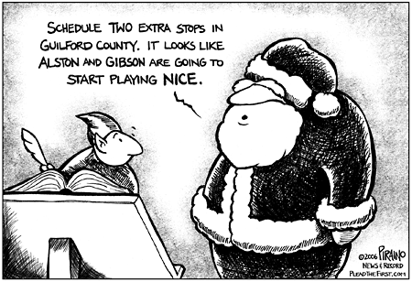



☺Merry Christmas Stephanie!! ☺

